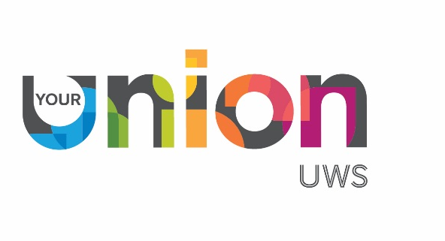

Annual General Meeting Minutes
Thursday, 13th of March 2025, Level 1 Paisley Students’ Union

Chair: Omowaleola Adebayo (President of UWS Students’ Union)
Attendance: Attended by 65 Students, UWS and UWS Union Staff including members of the Board of Trustees.

- Welcome
The Chair welcomed everyone to the meeting and thanked them for their attendance.

- Guest Speaker
Guest speaker, Professor James A. Miller, Principal and Vice-Chancellor of the University of the West of Scotland, addressed students on the theme “Empowering Student Voices: Shaping the Future Together.”

Professor Miller spoke about forthcoming challenges and the difficult decisions that lie ahead, while highlighting the many opportunities available for students to have their voices heard. He encouraged those present to become involved at all levels of representation, including as class representatives, student council members, or sabbatical officers, noting that there are opportunities for student involvement across the organisation.
In his closing remarks, Professor Miller encouraged students to actively engage and ensure that the student voice is heard.

The Vice President of Education thanked Professor Miller.

- The Power of Representation: Making Change Happen
The Chair of the Students’ Union Executive Committee, Gemma Murrell, delivered a presentation to the meeting.

- Swipe Up for success: last year in review & what’s next
The President delivered a short presentation outlining the Students’ Union, its purpose, and the services it provides. The President also presented the four strategic priorities that guide the Union’s work.

This was followed by a presentation from the Chief Executive Officer, who shared data on growth in student engagement for the last academic year. The CEO highlighted the importance of student representation in ensuring student voices are heard and encouraged attendees to become student representatives. The presentation also covered the role and importance of societies and the benefits of becoming a member.
The presentation detailed the range of support provided to students, including its Advice Service and initiatives addressing the cost of living.

The President concluded by providing an overview of the referendum, including its purpose and the process involved.

- Mic Drop – Paramedic Society in Action
The President of the Paramedic Society delivered a short presentation outlining the aims of the Society, highlighting recent events, and encouraged students to join.

- Minutes from last AGM
The minutes from the Annual General Meeting held on the 15th of February 2024 were approved at this meeting.

- Mic Drop – Midwifery Society in Action
The President of the Midwifery Society, accompanied by a Society member, delivered a presentation reflecting on how the Society empowers students. This included an overview of events organised and fundraising activities undertaken, and concluded with a reflection on the importance of Society membership to them both.

- Swipe Up for Transparency: The Audited Accounts Rundown –
The Deputy Chief Executive Officer (Finance & Governance), along with a Student Trustee, delivered a PowerPoint presentation on the year-end finances, highlighting the following points:

- We finished the year with a surplus of £42,406
- Our total income was £889,985
- £817,950 – Donations & Legacies
- £68,981 – Other Trading Activities
- £3,054 – Investment Income
- Expenditure: £847,579
- £821,853 - Charitable Activities
- £25,726 – Raising funds

- List of Affiliations: Voted on
The following list of affiliations were approved
- National Union of Students (UK & Scotland)
- Scottish Council of Voluntary Organisations
- Association of Colleges and Universities International - ACUI

10. Mic Drop - Debating Society in Action
The President of the Debating Society delivered a presentation highlighting the importance of their university experience and the sense of belonging gained through Society membership.
11. Presentation of Awards
The Associate Dean of Learning & Teaching at UWS presented certificates of appreciation
for Student Representation.
The Chair presented previous Board member, Mark McRitchie, with an honorary lifetime
membership of the Students’ Union in recognition of his service and contribution.

12. Ask Away: Student Questions for Our Trustees
This item on the agenda allowed attendees to raise questions, which were addressed during
the session.

13. Close
The Vice President of Education closed the meeting by thanking everyone for all their hard
work and support.

